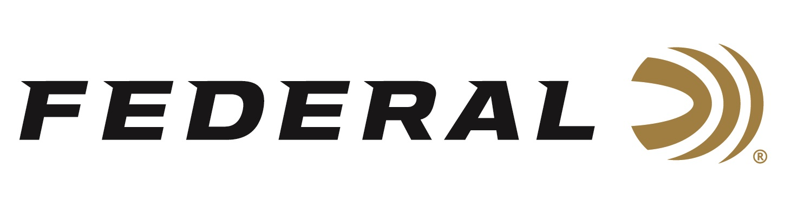

FOR IMMEDIATE RELEASE

Federal Ammunition Sponsored Shooter Derrick Mein Claims Trap Medals at World ISSF Championships

ANOKA, Minnesota – August 29, 2023 – Federal Ammunition congratulates sponsored shooter Derrick Mein on bringing home multiple medals from the ISSF Trap Championships in Baku, Azerbaijan.

Mein combined with teammates William Hinton and Derek Haldeman to win a gold medal in the Men’s Team Trap competition. “This was the first time since 1991 that our men’s team won the world championship. It’s always great to be a part of a historical moment,” stated Mein. The U.S. team finished one target ahead of second place Italy and three targets in front of the Czech Republic, who won bronze.

Mein then partnered with Rachel Tozier to bring home a silver medal in the Trap Mixed Team competition over 46 other world entrants. The former Olympian was perfect in his 75 targets, but the U.S. was edged by Portugal for gold. “My partner and I shot well; we just came up a little short in a sudden death shoot off. Being fortunate enough to win two medals is awesome,” said Mein.

Finally, Mein, a Kansas native, finished fifth in the individual Men’s Trap Championship. Mein qualified for the finals in sixth position and was able to move up one spot in the finals but fell short of a medal position. “Up next for me is the Pan American games in Chile. This is an event I’ve always wanted to participate in and will be going in with momentum and elevated expectations. I look forward to the challenge,” said Mein. Following the Pan American games, Mein reports he will focus his attention on completing the Olympic trials and heading to Paris as a member of the United States Trap team at the 2024 Olympics.

“We are fortunate to have elite athletes like Derrick Mein represent Federal Ammunition on the world stage,” said Jason Nash, V.P. of Marketing at Federal Ammunition. “Since winning his first world championship last year in Croatia, he has anchored medal performances in multiple World Cup team events in 2023 to add to his impressive resume.”

Federal is the number one choice for shotgun shells and manufactures products in America for all competitive and recreational disciplines. See the full lineup, including the latest High Over All, at www.federalpremium.com.

Federal ammunition can be found at dealers nationwide. For more information on all products from Federal or to shop online, visit www.federalpremium.com.

Photo credit: USA Shooting

Press Release Contact: JJ Reich
Senior Manager – Press Relations
E-mail: VistaPressroom@VistaOutdoor.com

About Federal Ammunition
Federal, headquartered in Anoka, MN, is a brand of Vista Outdoor Inc., an outdoor sports and recreation company. From humble beginnings nestled among the lakes and woods of Minnesota, Federal Ammunition has evolved into one of the world's largest producers of sporting ammunition. Beginning in 1922, founding president, Charles L. Horn, paved the way for our success. Today, Federal carries on Horn's vision for quality products and service with the next generation of outdoorsmen and women. We maintain our position as experts in the science of ammunition production. Every day we manufacture products to enhance our customers' shooting experience while partnering with the conservation organizations that protect and support our outdoor heritage. We offer thousands of options in our Federal Premium and Federal® lines-it's what makes us the most complete ammunition company in the business and provides our customers with a choice no matter their pursuit.

